Jeecs

HOW YOU CAN HELP

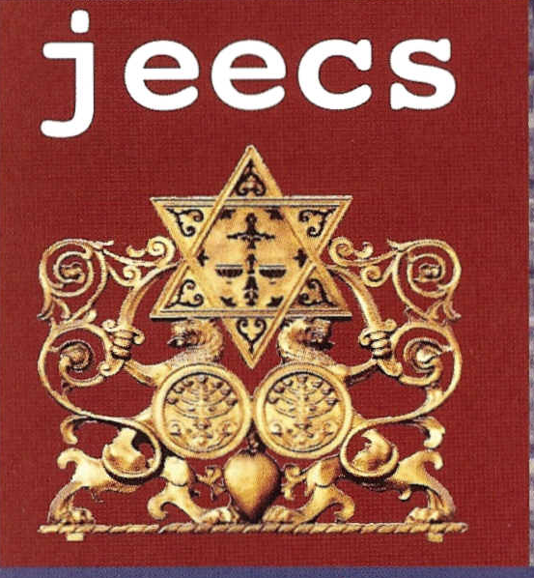
Please join the Jewish East End Celebration Society by completing the form below. Your generosity helps us preserve, document and celebrate this unique heritage for future generations of all backgrounds. Members will be informed of progress and activities, invited to special events, and have advance information about and be entitled to discounts at events as well as free copies of The Cable.

Annual membership fee: minimum £25; families £40

Please enrol me as a member of JEECS

Name ..........................................................................

Address ....................................................................

....................................................................................

Post Code Tel. ............................

Email ...............................................................

I enclose a cheque (payable to "JEECS") for £..........
I would like to make a one-off donation □
I am a UK taxpayer. Please treat my donation under gift aid □
I would like to pay by standing order (details below) □

To: The Manager (name of bank) ..............................................

(address).....................................................................................

..................................................................................................

(postcode)..................................................................................

Please pay National Westminster Bank plc, 18 Northumberland Street, Newcastle upon Tyne NE1 7EL, for the credit of: Jewish East End Celebration Society, Charity Reg No: 1107714.
Sort Code: 54 10 31. Account Number: 13564331

The sum of (in words) ............................................... pounds (£.......) on the (day)........ (month)........................

(year)..........and on the same day each year until further notice and debit my account accordingly.

Account to be debited (name):..............................................................................................................................

Account Number .......................................................... Sort code ...................................

Signed......................................................... Date.............................................

Send to: Jewish East End Celebration Society P.O. Box No 57317, London E1 3WG.
Jeecs is a registered charity: 1107714 Web: www.jeecs.org.uk Email: c.bettington@jeecs.org.uk Tel: 07941 367 882

